PLEASE FILL OUT AND RETURN THIS FORM
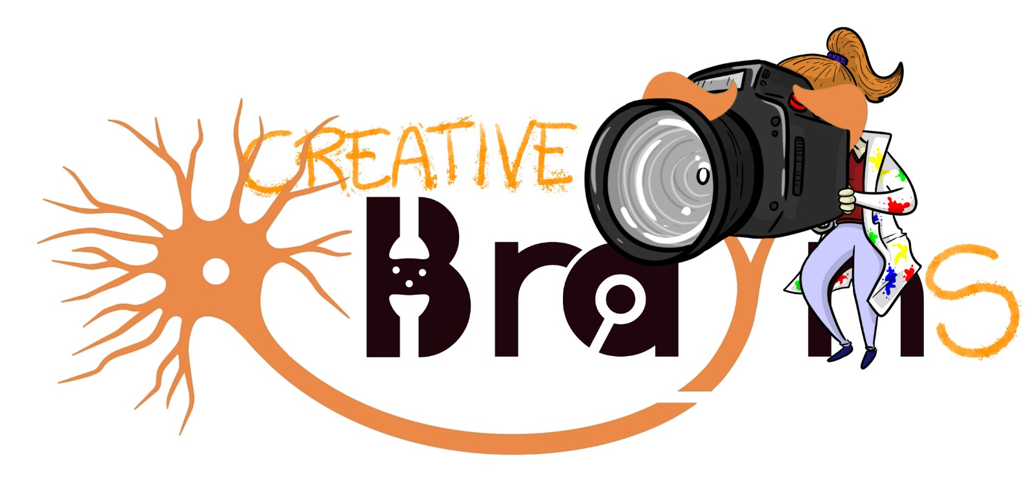
E-mail: info@braynassociation.com

Consent form for photo publication (Mandatory Declaration Form)

Photo Title _____________________________________________________________________

The submitting author (in capitals) __________________________________________________
give explicit consent to the BraYn Association to use the picture for the Creative BraYns contest that will be held during the 7th edition of the BraYn Conference on 9-11 October 2024.

By submitting a photo, the author accepts participation in the 'Creative BraYns' competition and declares under their responsibility that they own all rights to the uploaded images.
The author also understands that their material can be used free of charge on any media, including the BraYn website and social media.

Date (dd/mm/yyyy) Signature

